**GMM(Gaussian mixture matrix) :**

**→ Gaussian mixture model is also a clustering technique, just like k-means with a slight variation .**

**→ It is also another technique of un-supervised learning .**

**→ Gaussian means it is nothing but a bell curve that have a center (mean) and It has standard deviation .**

**(1) read our image and reshape it .**

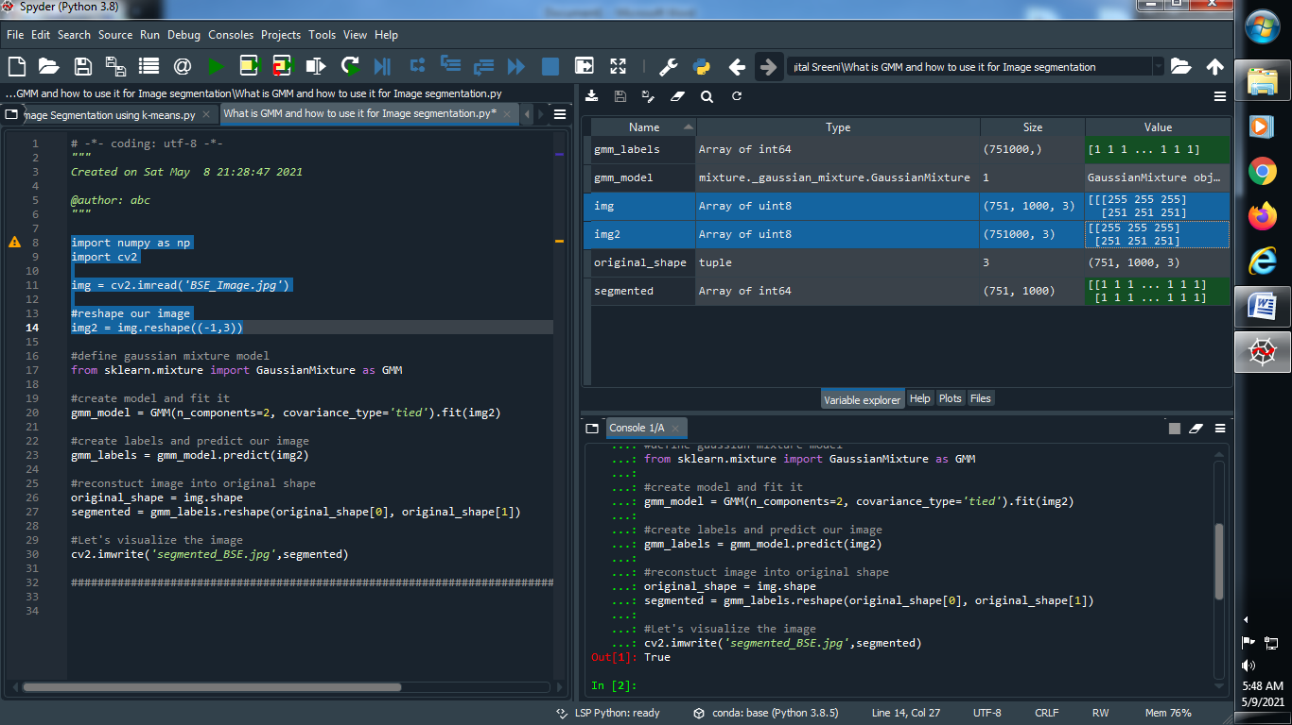

**Output :**



**(2) Define Gaussian mixture model .**

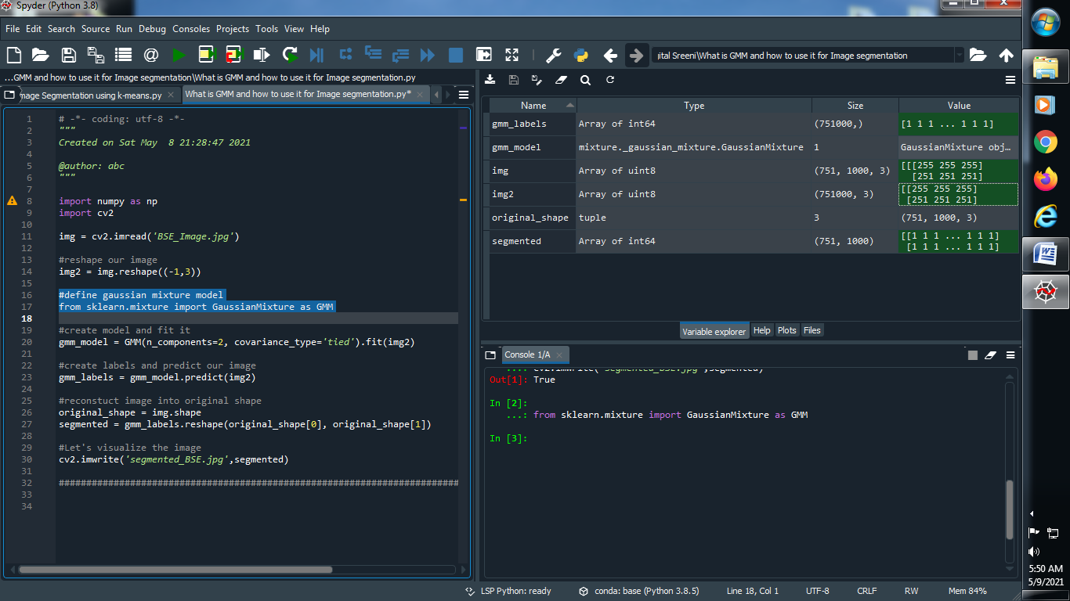



**(3) Create a model and fit it .**

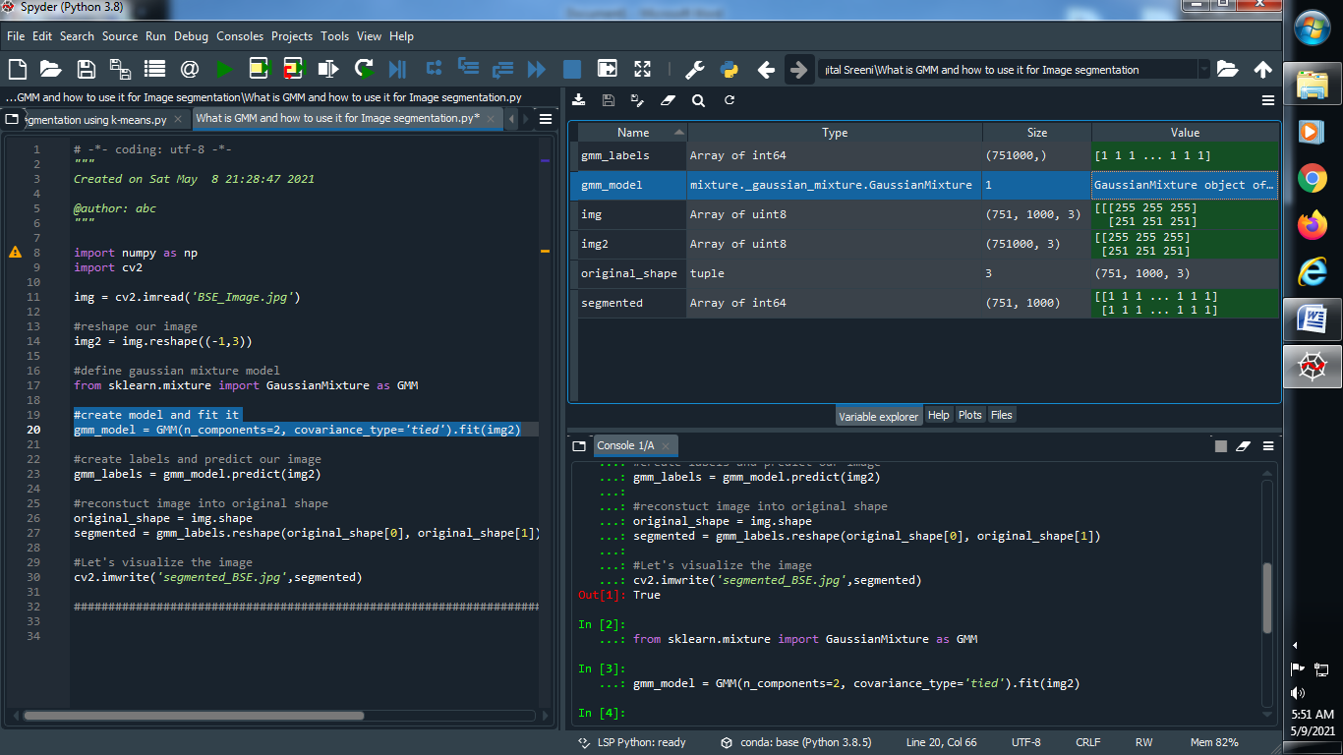

**Output :**



**(4) Create labels and predict our image :**

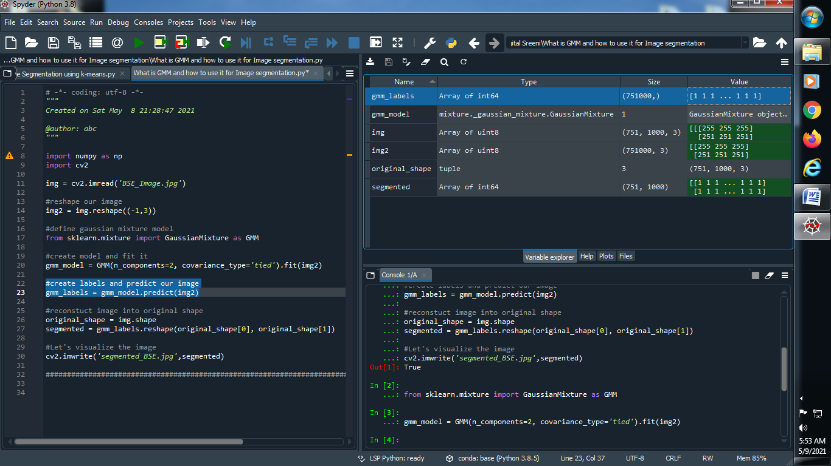

**Output :**



**(5) Reconstruct image into original shape**

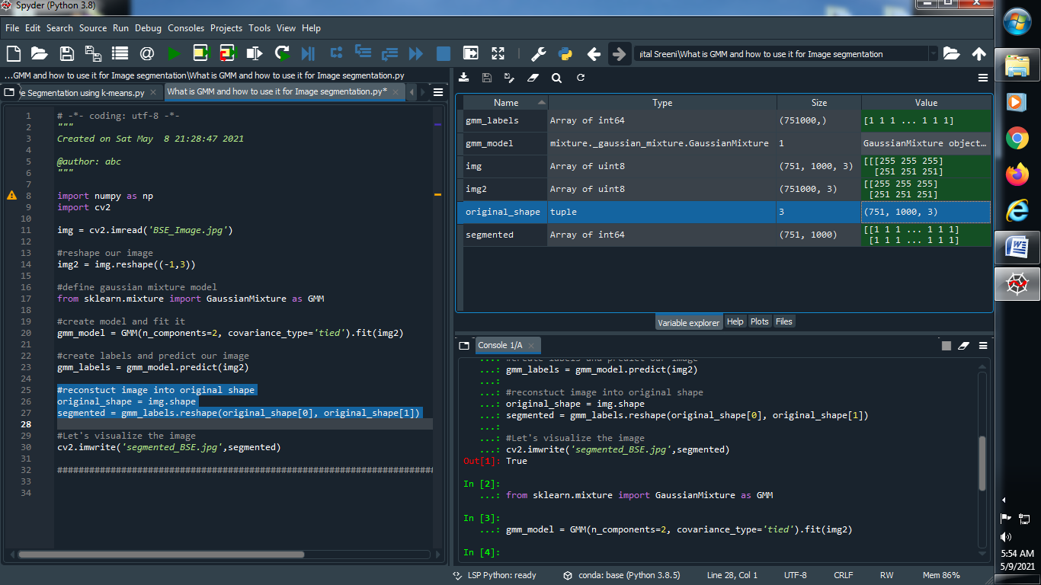

**Output :**



**(6) Let’s Visualize our image :**

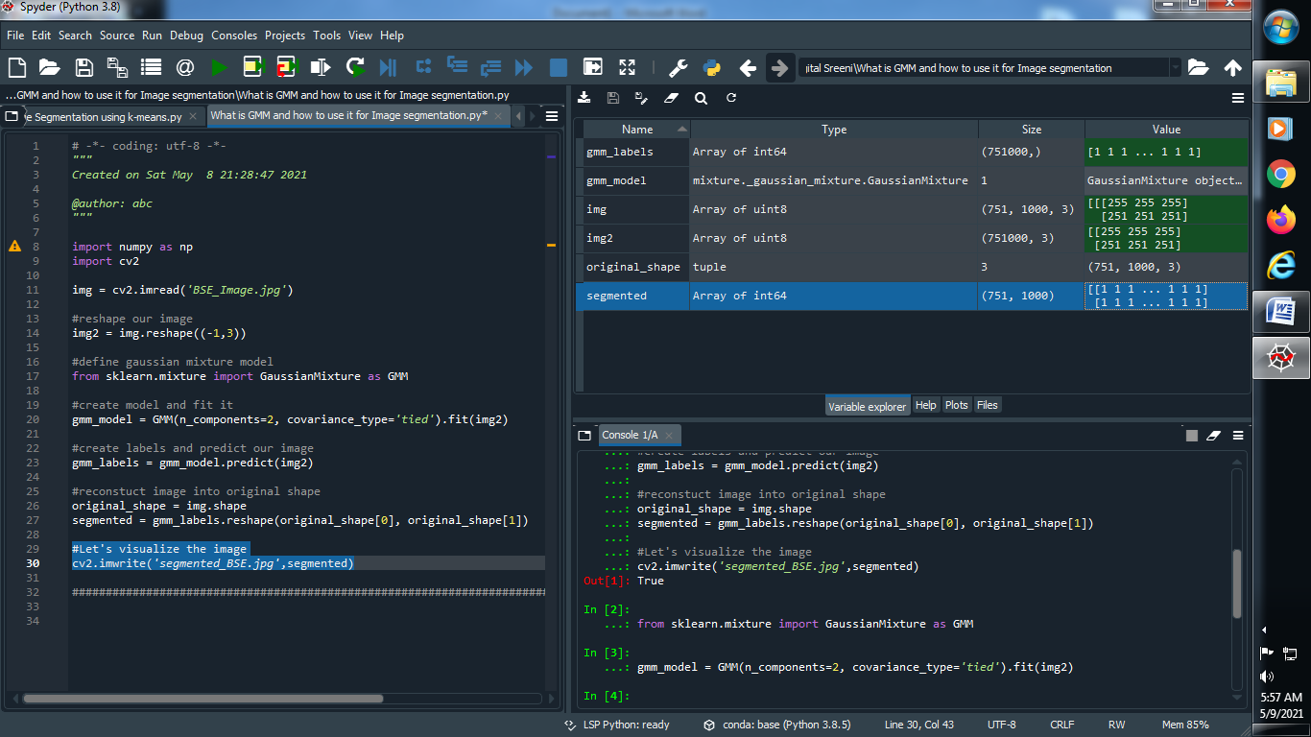

**Output :**



**Original Image :**

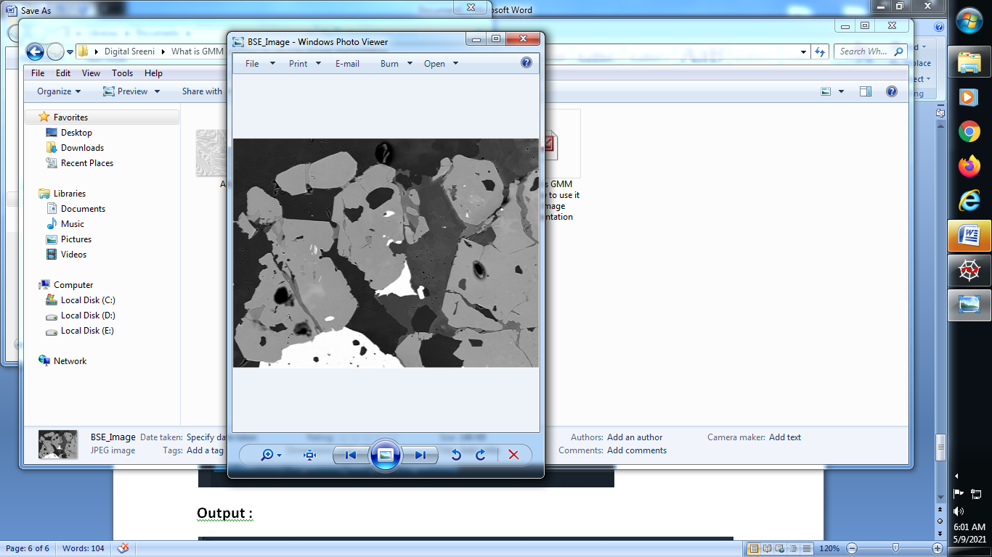

**Segmented image :**

